Superscan:

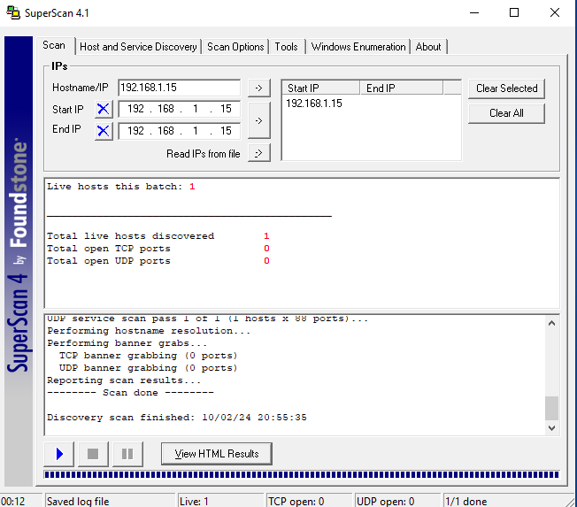

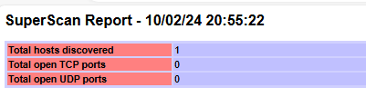

Netbios Vulnerability:

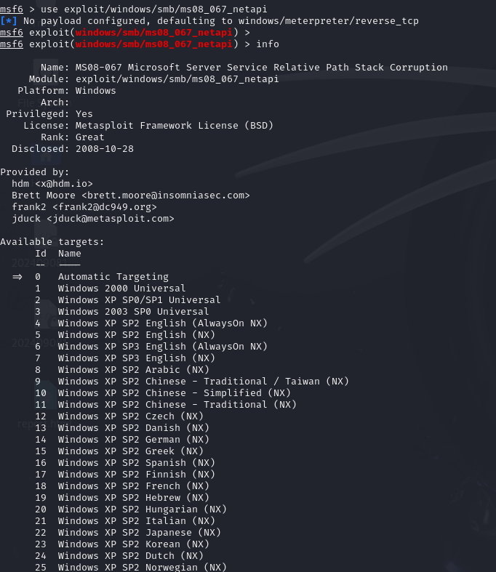

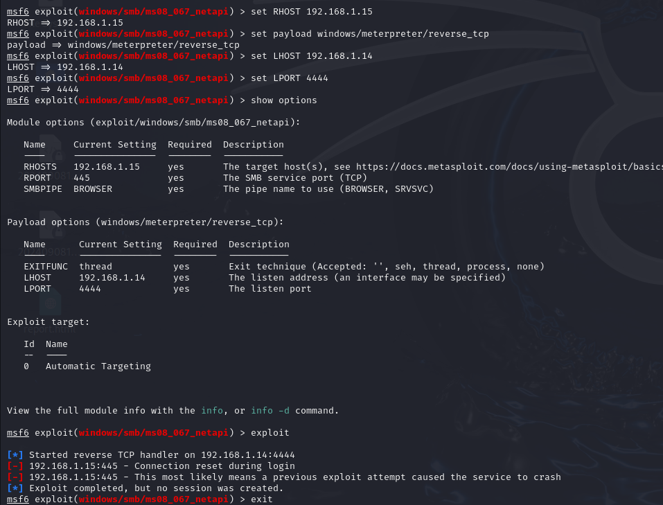

Since NetBIOS vulnerability works on older version of windows such as Windows XP, Windows 2003, 2002 etc. it didn’t work for windows 10 as this vulnerability is patched.

Trying Eternal Blue:

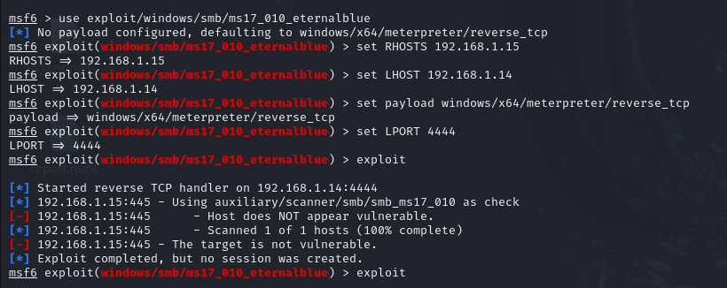

Since Eternal Blue works on older version of Windows 7 it didn’t work in windows 10 even after enabling SMB1Protocol, this vulnerability has been patched in windows 10.

SQL Injection Using SQLMAP (Getting Database):

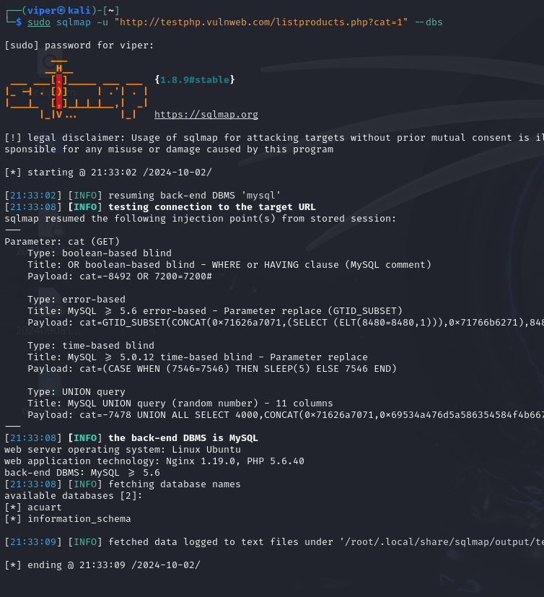

Getting Tables in Database “acuart”:

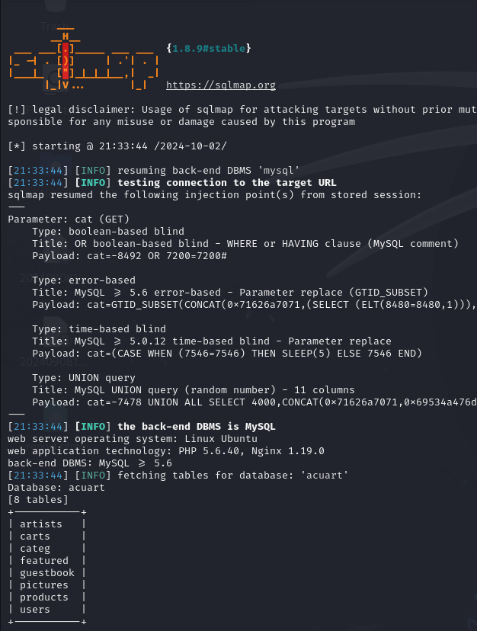

Dumping Data from table “users”:

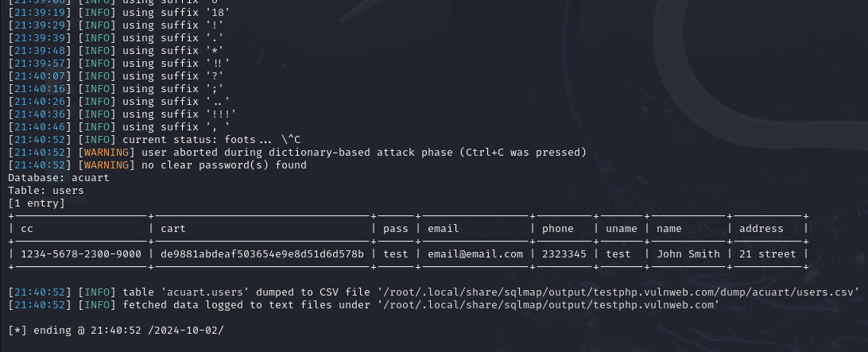

SQLINJECTION and METASPLOIT:

Creating Backdoor Payload using Metasploit:

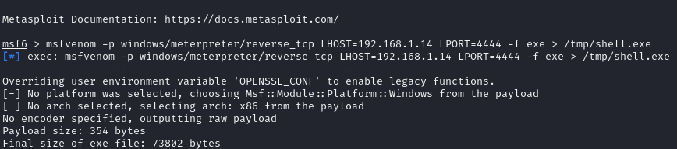

Trying to upload the backdoor file on the database server of vulnerable website:

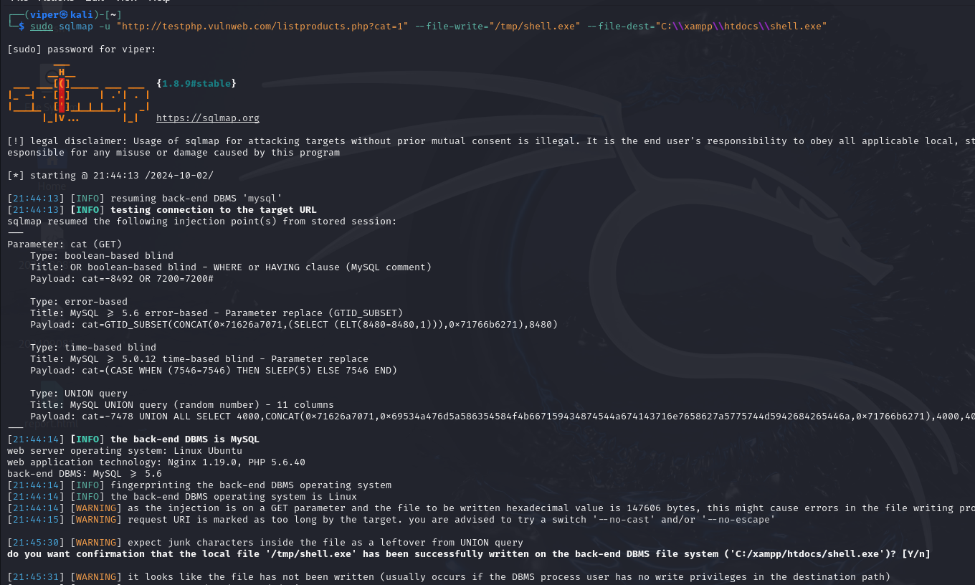



It seems the website is vulnerable to sql injection but doesn’t have write permissions so the file didn’t get uploaded

Trying other method to upload file:

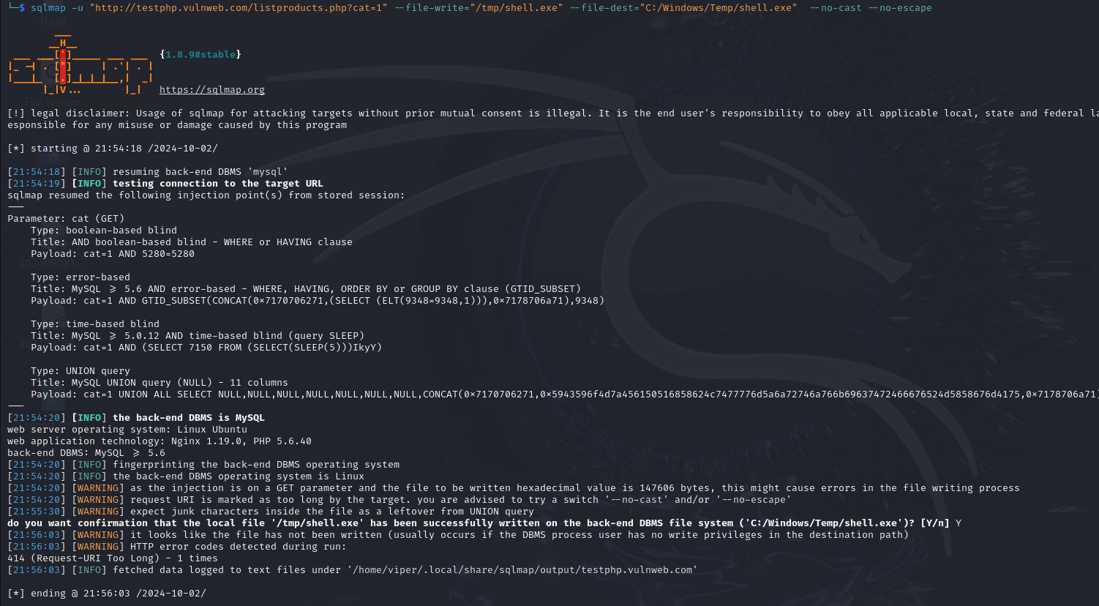

The website is not vulnerable to uploading the file so the backdoor file will not be uploaded and we will not be able to get it downloaded on other system and get the systems acccess